**dAOA**

By Ron Stark

Advantzware, Inc.

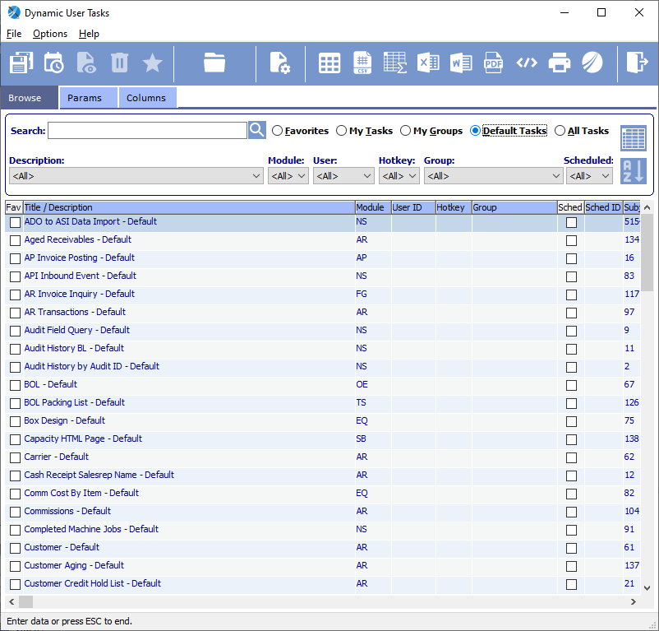

Dynamic Advantzware Open Analytics: User Tasks - Guide

Table of Contents

Main Menu 6

Icons 6

Dynamic Task Results 7

• View 7

• Archive 7

• Delete 7

• Refresh 7

• Toggle Sort Columns 8

Dynamic User Tasks 8

• Save As 8

• Scheduler 9

• Set Description, External Form Record Limit & Favorite 9

• Delete 9

• Favorite 9

• User Tasks (HTML Page) 9

• Page Format 9

• Grid 10

• Local CSV 10

• CSV 10

• XLS 10

• DocX 10

• PDF 10

• HTML 10

• Printer 10

• Page Format 11

• Jasper Viewer 12

• Browse [Tab] 14

o Task Filter 14

o Filters 14

o Toggle Sort Columns 14

o Move Columns 14

o Search 14

• Params [Tab] 15

o Email (recipients) 16

o Run Synchronous 16

o Auto Close 17

o Default Output Format 17

o Show [toggle boxes] 17

o Save 17

o Reset 17

• Columns [Tab] 17

o Advanced 18

o Move Up 18

o Move Down 18

o Add Sort/Group 18

o Remove Sort/Group 18

o Update / Save 18

o Reset 18

o Group Calculations 18

Dynamic Task Scheduler 20

• Run Now 20

• View 20

• Toggle Sort Columns 20

• Move Columns 20

• Show Tasks 20

• Show History 20

• Search 21

• Close (viewer) 21

• Update / Save 21

• Add 21

• Copy 21

• Delete 21

• Reset 21

• Cancel 21

• Run Now 21

• First 21

• Previous 21

• Next 21

• Last 21

• Task Scheduler Fields 21

o Parameter Value/Task ID 21

o Task Name 21

o Security Level 21

o Scheduled to Run 21

o Frequency 21

o Start Date 21

o End Date 22

o Next Date 22

o Next Time 22

o Last Date 22

o Last Time 22

o Run Synchronous 22

o Run Now 22

o Format 22

o Recipients (email) 22

o Subject ID 23

o User ID 23

o Program 23

o Title 23

o Module 23

Task Monitor (ND1) 24

• Show Logging 24

• Hide Logging 24

• Clear Is Running 25

• Clear (Pending Emails) 25

System Configuration (NS3) 26

• Configurations Fields 26

o Email Subject 26

o Cue Card Notification 26

Task Result / Cue Card Alert 27

Email Configuration (NS10) Task Recipients 28

Email Configuration (NS10) Task Monitor Not Running Notification 29

Jasper Starter 30

• Installation 30

• Verification of install 34

Main Menu Dynamic User Tasks have three components that are accessed via icons located on the top row of the Main Menu, along with Menu Options Task Monitor (ND1) and Configurations (NS3).

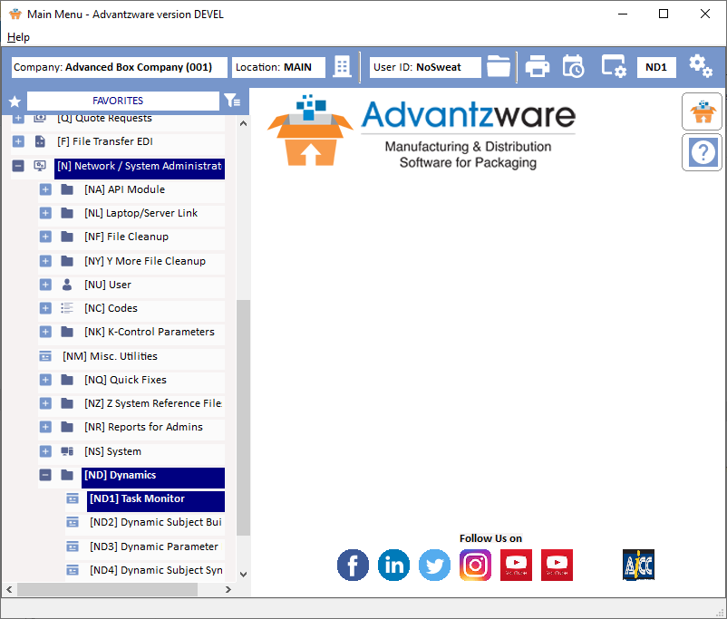

**Note**: lower left corner shows Task Monitor Last Executed: [Date] [Time] which auto refreshes every 10 seconds when Task Monitor is running.

Icons

1.  **Dynamic Task Results**
2.  **Dynamic User Tasks**
3.  **Dynamic Task Scheduler**
4. **Task Monitor (ND1)**
5. **Configurations (NS3)**

Dynamic Task Results  presents a display of Task Result files which are the generated result from a user’s Run Now  submitted request and/or Tasks executed from within the Task Monitor of Tasks scheduled from the Dynamic Task Scheduler .

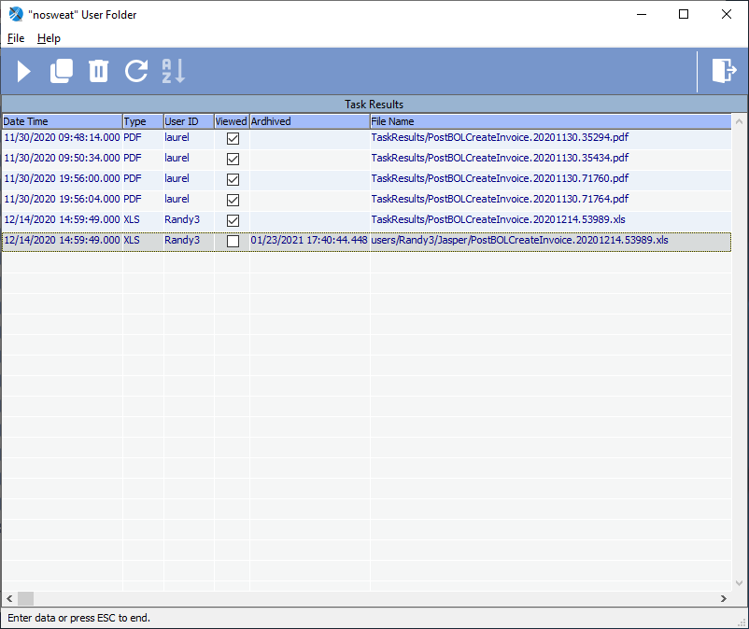

* View  executes the associated application (cvs: exel, xls: excel, docx: word, pdf: pdf, html: web browser) of the Task Result selected and the Viewed column is set as checked.
* Archive  will create a copy of the selected Task Result into a user’s Jasper folder and log the date and time of the archive.
  + TaskResults/PostBOLCreateInvoice.20201214.53989.xls will archive into
  + Users/Randy3/Jasper/ PostBOLCreateInvoice.20201214.53989.xls
* Delete  removes the selected Task Result entry and deletes the physical file from disk.
* Refresh  scans the folder “TaskResults” and local user folders for Task Result files to sync newly added and/or removed Task Results.
* Toggle Sort Columns , by default blue columns will sort the data when the blue column header is clicked, ascending and descending. Clicking to toggle this icon, changes from sort from ascending to descending and vis versa.

Dynamic User Tasks  contains Tasks (Dynamic Parameter Value records) built on Dynamic Subjects (ND2) and Dynamic Parameters (ND3) can be identified by the User ID of “_default” along with a Description of Subject Title and “- Default”. Tasks are shown where the Security Level of the Task is less than or equal to a User’s Security Level (NU3 Users). A Task is associated with Parameters [tab] and selectable Columns [tab]. Tasks generated here inherit the Security Level of the User that generates the Task and identified with a Description of Subject Title and Custom entered description. User ID “_default” Tasks cannot be altered and/or deleted. These are maintained by Advantzware.

* 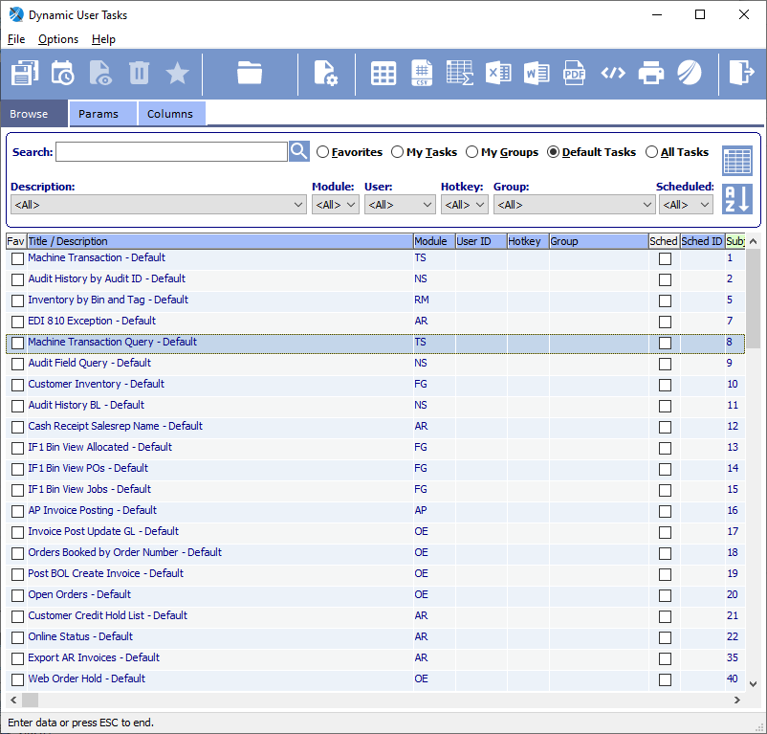
* Save As , in order to Schedule a Task, a Parameter Value ID that is non-zero is required. Executing a Save As will prompt to Enter Task Description. This process will create a unique Parameter Value ID. This Value ID is used when adding a Task into the Dynamic Scheduler , which can be accessed via the Main Menu  Calendar icon.
* Scheduler , allows easy access to the Dynamic Scheduler , which can also be accessed via the Main Menu  Calendar Icon. (See Dynamic Scheduler documentation within this document).
* Set Description, External Form Record Limit & Favorite , By default, the New Dynamic framework renders the output utilizing Jasper Reports. The Dynamic framework auto generates the Jasper Report, however, a custom, static Jasper Report can be utilized by designating the location and name of the .jrxml file. Some Dynamic Queries may return a large data set. To limit the amount of data returned, a Record Limit value can be designated. A zero value will return all data of the Dynamic Query.
* 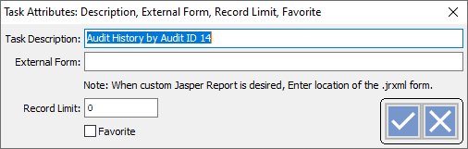
* Delete , prompts to remove a Task.
* 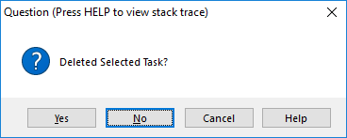
* Favorite , toggles a Task as a Favorite or not.
* User Tasks (HTML Page) , creates an HTML formatted web page showing a user’s Scheduled Tasks and Task Results.
* Page Format , invokes the Page Format Selection popup, which sets the Page Orientation, Height and Width. Note: although a Page Width value is shown, the Jasper Report generator auto calculates this value.
* 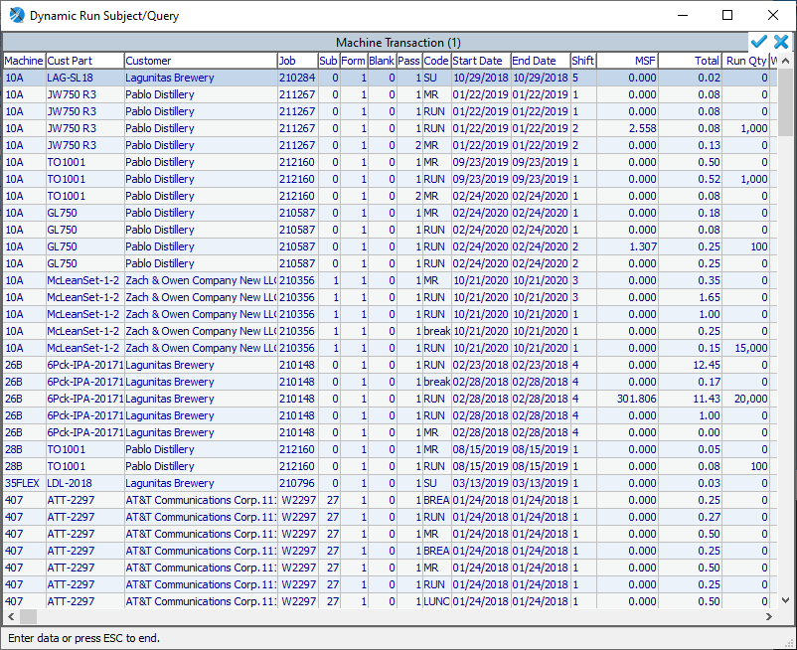
* Grid  renders the dynamic query results to a grid browser. Columns can be re-arranged and column widths can be re-sized and saved.
  + Save  will Save any column order and width changes.
  + Cancel  will close the Grid and return to the Parameter screen.
* Local CSV  creates an Excel CSV which is run and launched locally without using the Task Monitor.
* Note: when selecting any of the next five options (CSV, XLS, DocX, PDF, HTML) the Task is submitted for processing by the Task Monitor and will prompt with:
* 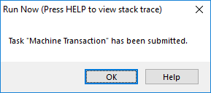
* CSV  creates an Excel CSV Task Result.
* XLS  creates an Excel Task Result.
* DocX  creates a Word Task Result.
* PDF  creates a PDF Task Result.
* HTML  creates a HTML Task Result.
* Printer  invokes the Windows Printer Dialog popup.
* 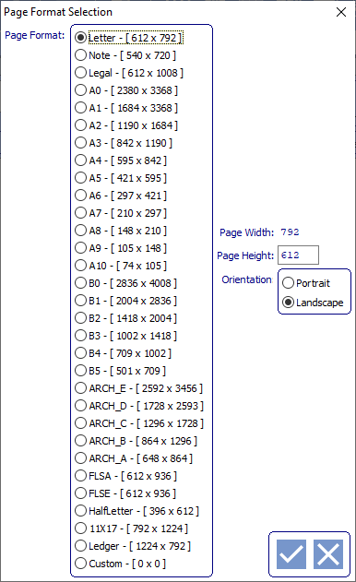
* Page Format  invokes the Page Format Selection popup, which sets the Page Orientation, Height and Width. Note: although a Page Width value is shown, the Jasper Report generator auto calculates this value.
* 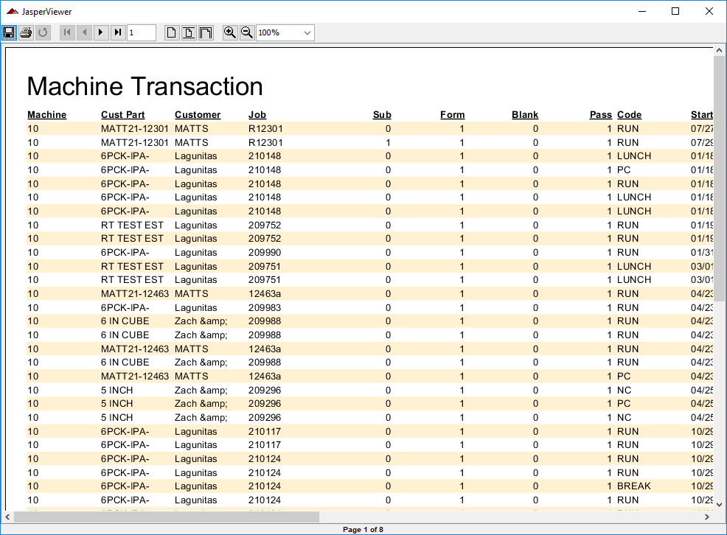
* Jasper Viewer  will run the query results to Jasper Viewer if Jasper Starter is installed locally. When a Viewer session is invoked, a background command window renders and will remain open until the Viewer is closed.
* 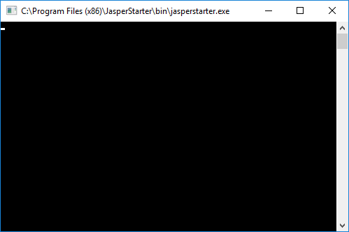
* Viewer command window.
* 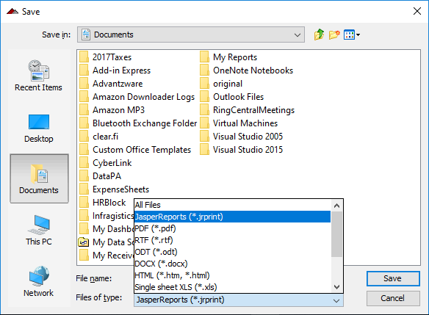
* Viewer allows the user to Save the results into various formats.
* 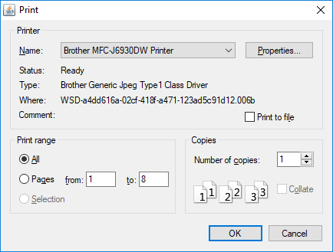
* Viewer has ability to select and send results to a printer device.
* Easily navigate to First, Previous, Next, Last Page.
* 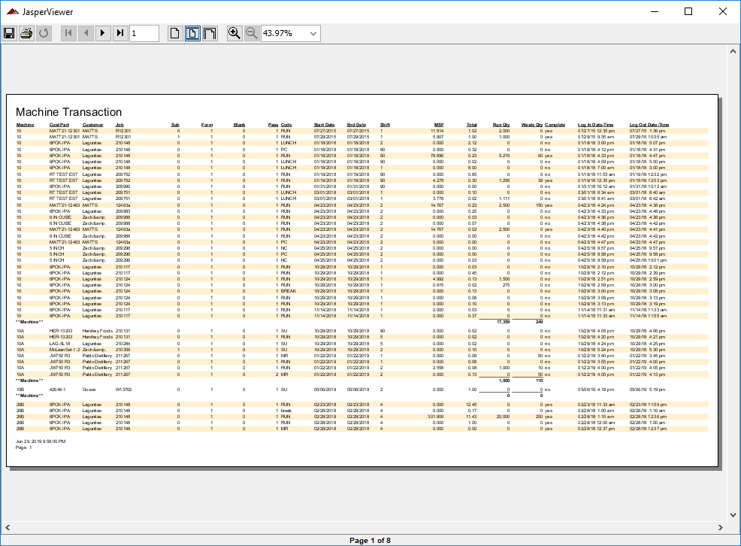
* Results can be auto sized to fit the Viewer
* Viewer has functionality to zoom in/out and/or set the display relative percentage size.
* Browse [Tab] is the main point of navigation and access to Dynamic User Tasks.
  + Task Filter can be used to filter the available records based on Favorites, My Tasks (User ID), My Groups, Default Tasks (User ID = _default) or All Tasks.
  + Filters can be used to filter the available records based on a Task’s Description, Module, User, Hotkey, Groups and/or Scheduled.
  + Toggle Sort Columns , by default blue columns will sort the data when the blue column header is clicked, ascending and descending. Clicking to toggle this icon, changes from sort from ascending to descending and vis versa.
  + Move Columns , will disable the Sort Columns icon and allow user to drop and drag columns to change the order.
  + Search  will locate and filter records that match the entered criteria found in the blue labeled columns.
* 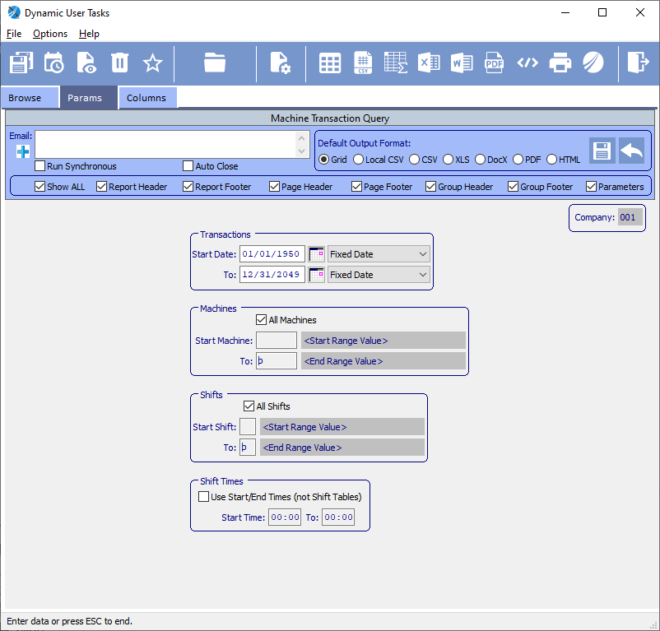
* Params [Tab] dynamically renders the Task’s parameters. Users set the Parameter values, along with one or more email recipients, the Default Output and to designate which various Jasper Report sections to Show/Not Show.
  + 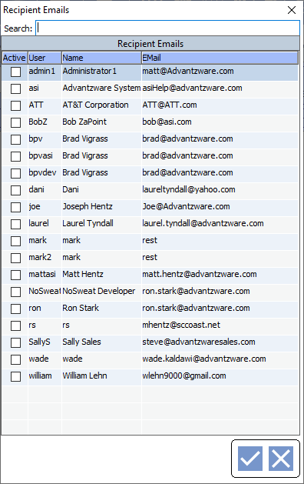
  + Email (recipients)  is a freeform field and relies on the user to enter email addresses properly formatted [*name@domain.com*](mailto:name@domain.com)*.* Clicking the “+” (plus sign) icon, the above popup is presented. It is populated with users (maintained in NU3 Users) which have an email field that is populated.
    - Search will auto locate and filter records that match the entered criteria found in the blue labeled columns.
    - Save  will auto display any Recipient Emails which have been selected via Active column that has been checked into the Recipients field. Any freeform emails entered will also appear and Active selected. Unchecking the Active column value will remove a freeform email.
    - Cancel  will close the Recipient Emails popup without applying any changes to the Recipients field.
  + Run Synchronous when checked causes the ND1 Task Monitor to run the Subject Synchronously without spawning a separate Progress session, thus avoiding using a seat license, however, the ND1 Task Monitor will cease processing any Tasks in the queue until the Synchronous Task has completed.
  + Auto Close indicates that after a Task is Submitted to CSV, XLS, DocX, PDF or HTML the Parameter screen will auto close.
  + Default Output Format allows the selected Task to set a default output to Grid, CSV, XLS, DocX, PDF or HTML.
  + Show [toggle boxes] allows for the various sections of the Jasper Report to be rendered. Show All will toggle all the values ON or OFF. The various sections include Report Header/Footer, Page Header/Footer, Group Header/Footer and if showing the Parameter values on the last page is desired.
  + Save  will capture any changes to the Parameter values.
  + Reset  will restore Parameter values previous settings.
* 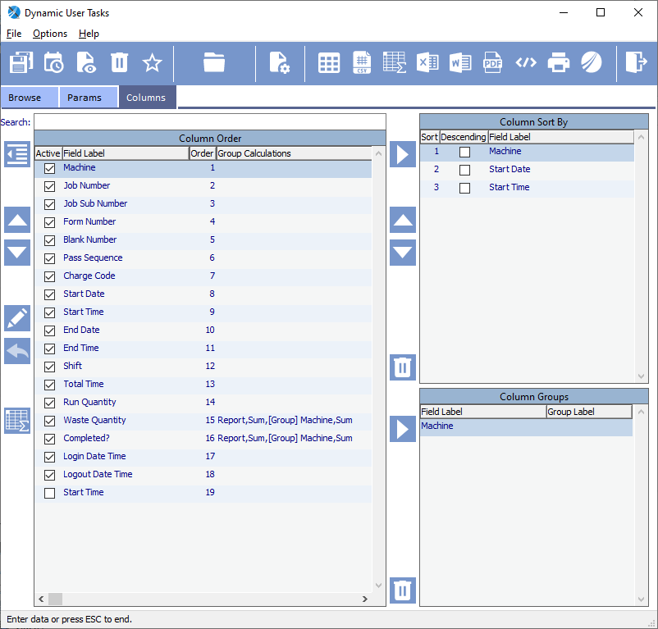
* Columns [Tab] allows for changing the order in which the columns render, setting which columns to sort the report, whether a column is ascending/descending, designate a column as a group for summing, count, average, low value, high value and/or custom calculations, provide a custom group label. To change any of the previously listed columns, simply click into the desire and column and row. After changing the value, tab out of the field or hit ENTER.
  + Advanced  will expand the Column Order browser to show additional columns Order and Group Calculations.
  + Move Up  icon to the left of a browser will move the selected column up in the order.
  + Move Down  icon to the left of a browser will move the selected column down in the order.
  + Add Sort/Group  icon to the left of a browser will add the selected Column Order record to the Sort or Group browser accordingly.
  + Remove Sort/Group  icon to the left of a browser will remove the selected record from the Sort or Group browser accordingly.
  + Update / Save  /  will enable if any changes are done by changing the column order, add a sort or group, and/or remove a sort or group. Clicking the Update icon will enable the Active, Field Label and Descending fields (this will disable the move, add and remove icons until a save or reset operation is performed).
  + Reset  will reset any changes up to the last save operation.
  + 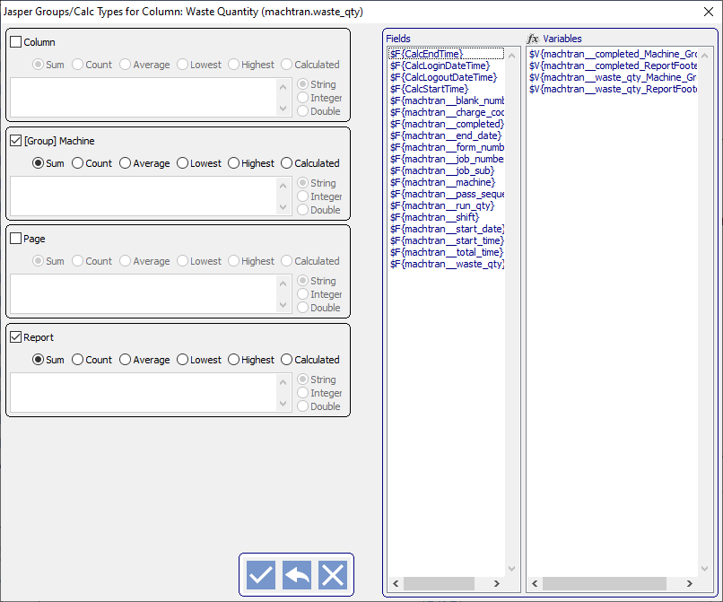
  + Group Calculations  will only appear when a Task’s User ID is NOT “_default”. There are three default Groups (Column, Page and Report). If any Column was designated as a Group, that Column will also appear labeled [Group] <Column Label>. In the above image, Machine was selected as a Group and appear as [Group] Machine for the Column Run Qty. Groupings have the option to Sum, Count, Average, Lowest (value), Highest (value) or Calculated. Calculated values can be of data type Character, Integer (non-decimal numbers) or Double (decimal numbers). When building a Calculated value, Fields and Variables are available. Simply place focus into the editor of the Grouping and double click a desire Field and/or Variable. This editor is freeform and requires the user to ensure properly formatted formulas. The nomenclature used for Fields $F{table.field} and Variables $V{table.field_group} is recognized by the Jasper Framework and is formatted to match the auto generated Jasper Report syntax.
    - Save  will Save any changes entered and exit the popup.
    - Reset  will restore any changes values to their prior setting.
    - Cancel  will ignore any changes entered and exit the popup.

Dynamic Task Scheduler 

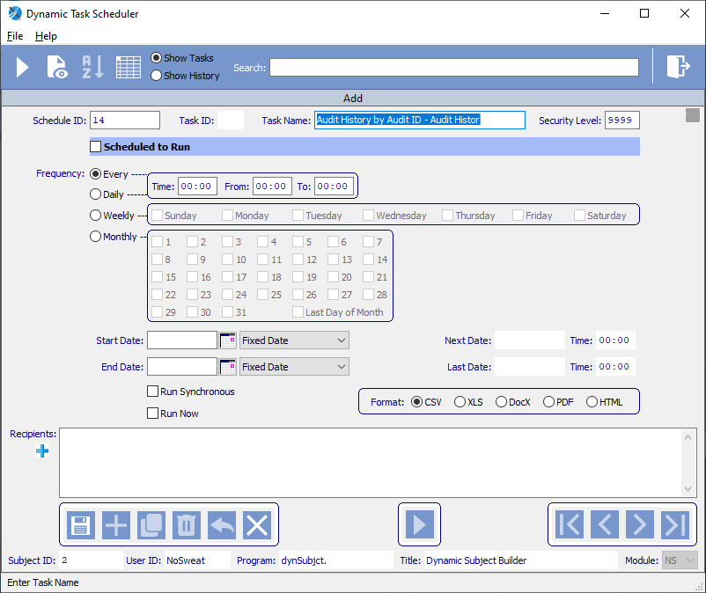

* Run Now  will submit the selected task to the Task Monitor (ND1) for execution using the Parameter values associated with the Subject/Parameter Value ID.
* View  toggle the View of the selected Task to open, if closed, which allows the user the functionality to Update/Add/Copy/Delete a Task, or to close the Viewer, if open.
* Toggle Sort Columns , by default blue columns will sort the data when the blue column header is clicked, ascending and descending. Clicking to toggle this icon, changes from sort from ascending to descending and vis versa.
* Move Columns , b will disable the Sort Columns icon and allow user to drop and drag columns to change the order.
* Show Tasks shows current list of Tasks.
* Show History shows the Audit History of the selected Task. Audit History can be accessed via Menu Option NS5.
* Search will auto locate and filter records that match the entered criteria found in the blue labeled columns.
* Close (viewer)  closes the detail view when open.
* Update / Save  /  when the first icon is a pencil, will place the View into UPDATE mode and changes the icon to a floppy disk, when performs a SAVE operation, after which will change back to the pencil image.
* Add  creates a new blank Task and prompts for a Parameter Value ID generated in Dynamic User Tasks , which accessed via the Main Menu  Printer Icon.
* Copy  create a copy of the currently selected Task. This allows the same Parameter Value ID to be used numerous times with differing Scheduled Dates and Times.
* Delete  will remove the selected Task.
* Reset  when in Update/Copy mode will restore the field values of any changed fields to their original values.
* Cancel  when in Update/Add/Copy mode, will cancel the selected mode and return to View mode.
* Run Now  will submit the selected task to the Task Monitor (ND1) for execution using the Parameter values associated with the Subject/Parameter Value ID.
* First  positions to the First Task record.
* Previous  positions to the Previous record relative to the currently selected Task.
* Next  positions to the Next record relative to the currently selected Task.
* Last  positions to the Last Task record.
* Task Scheduler Fields
  + Parameter Value/Task ID is generated within Dynamic User Tasks , which is accessed via the Main Menu  Printer Icon and validated against an existing Dynamic Parameter Value record.
  + Task Name during an Add operation will auto populate from the Dynamic Parameter Value record and can be over written.
  + Security Level auto populated with the user’s security level (set in NU3 Users) performing an Add/Copy operation.
  + Scheduled to Run allows the Task Monitor (ND1) to execute a Task on a predetermined Frequency/Next Date/Next Time values. When unchecked, no Next Date/Next Time values will exist.
  + Frequency options Every, Daily, Weekly and Monthly (Note: time entries are to be entered in military time format)
    - Every option
      * Time interval between when a Task is submitted for execution.
      * From starting time of day when a Task can first be submitted.
      * To ending time of day when a Task will cease to be submitted.
    - Daily option relies on the time entered to indicate at what time of the day for a Task to be submitted.
    - Weekly option relies on the time entered to indicate at what time of the day and one or more days of the week, Sunday, Monday, Tuesday, Wednesday, Thursday, Friday, Saturday for a Task to be submitted.
    - Monthly option relies on the time entered to indicate at what time of the day and one or more days of the month from 1 to 31, and/or Last Day of Month for a Task to be submitted.
  + Start Date if populated indicates the when a Task can start to be submitted.
  + End Date if populated indicates when a Task will cease to be submitted.
  + Next Date is read only and will auto populated during a Save operation when a Task Scheduled is checked and is based on the values of Frequency and Time(s).
  + Next Time is read only and will auto populated during a Save operation when a Task Scheduled is checked and is based on the values of Frequency and Time(s).
  + Last Date is read only and is auto populated by the Task Monitor when a Task was last submitted.
  + Last Time is read only and is auto populated by the Task Monitor when a Task was last submitted.
  + Run Synchronous when checked causes the ND1 Task Monitor to run the Subject Synchronously without spawning a separate Progress session, thus avoiding using a seat license, however, the ND1 Task Monitor will cease processing any Tasks in the queue until the Synchronous Task has completed.
  + Run Now is auto set by the Task Monitor when a Task has been submitted as a Run Now operation. If a Task fails to complete in the Task Monitor and the Run Now flag remains set, the Task will remain in the Task Monitor queue. Unchecking this value will allow the Task Monitor to auto remove it from the queue.
  + Format indicates the default output format.
  + 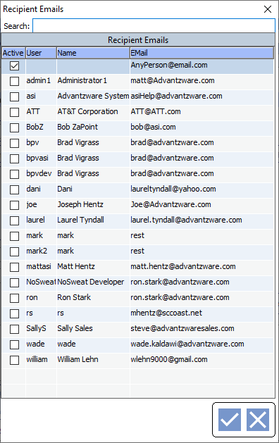
  + Recipients (email)  is a freeform field and relies on the user to enter email addresses properly formatted [*name@domain.com*](mailto:name@domain.com)*.* Clicking the “+” (plus sign) icon, the above popup is presented. It is populated with users (maintained in NU3 Users) which have an email field that is populated.
    - Search will auto locate and filter records that match the entered criteria found in the blue labeled columns.
    - Save  will auto display any Recipient Emails which have been selected via Active column that has been checked into the Recipients field. Any freeform emails entered will also appear and Active selected. Unchecking the Active column value will remove a freeform email.
    - Cancel  will close the Recipient Emails popup without applying any changes to the Recipients field.
  + Subject ID is read only and auto populated with the values found in the Dynamic Parameter Value record.
  + User ID is read only and auto populated with the user id of the user performing an Add/Copy operation.
  + Program is read only and auto populated with the Program ID, maintained in the Program Master (NS8), which exists in the Dynamic Parameter Value record.
  + Title is read only and auto populated from the Program Master (NS8) Title value, using the Program field value.
  + Module is read only and auto populated with the values found in the Dynamic Parameter Value record.

Task Monitor (ND1) This module needs to be in a constant state of running to process Run Now submissions and/or entries found in the Task Scheduler which have their scheduled value checked. Ideally this Monitor should be started and running on a system server. It can be run from a client workstation but will span child Progress sessions in order execute and generate a Task Result process.

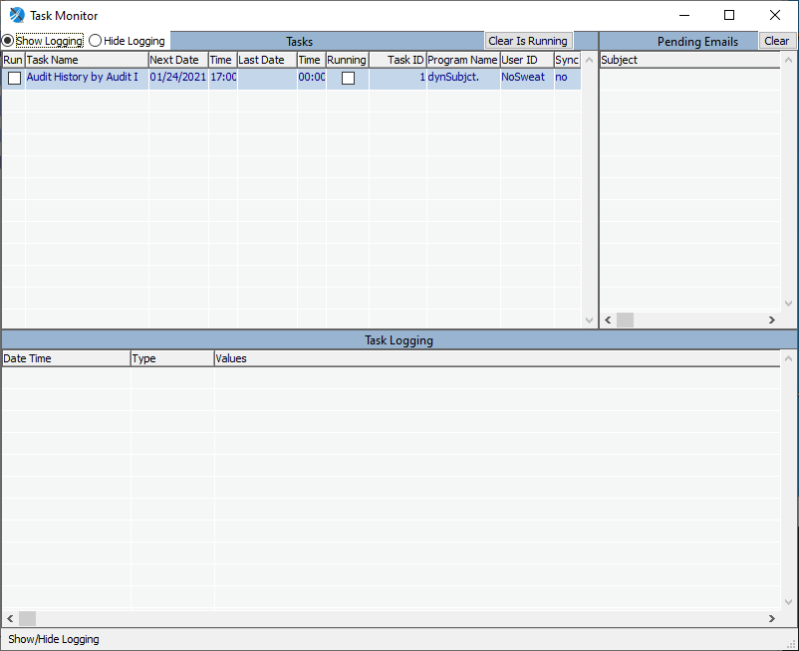

Each spawned process does use a Progress seat license and will remain active until the Task is complete and which time the session will disconnect and close itself. Any user can notice the Task Monitor is up and running by seeing the date and time in the lower left corner of the Main Menu change. The Task Monitor polls the queue entries every 10 seconds.

* Show Logging splits the display into an upper (Task in the Monitor queue) and a lower (Task Logging). The Task Logging displays entries that can be found in NS5 Audit History when a Task is executed and generally shows the generated Task Result. If a Task has email recipients, the execution of the email being sent is also recorded. The Task Logging entries displayed are only those which were created from the time the Task Monitor was opened. To view prior Task Logging, they are found in NS5 Audit History under the Audit Type “Task”.
* Hide Logging will close lower half of the display of Task Logging entries.
* Clear Is Running removes the Run (Is Running) checked value from queue entries. Under normal operations, this field is set when the Monitor has spawned a session to execute the Task. If any event occurs which prevents the spawned process from completing successfully, the queue entry may be in a perpetual state of Is Running. When a spawned progress is created, the monitor has no way of knowing how long the Task will take to complete. Setting the Is Running field prevents the monitor from spawning another session when one may already exist. When a spawned process completes, it removes the Is Running value. With a failed process, this will not occur. So, this function allows an administrator to manually clear the Is Running checked value(s).
* Clear (Pending Emails) will remove Pending Email entries from the monitor’s queue. An administrator may need to execute this function should an event prevent the successful execution of an email being generated and sent to designated recipients. Pending Email entries poll to ensure the attached Task Result exists on disk. If the spawned process to generate the Task Result fails, the polling by the Pending Email entry will never execute and remain within the Monitor’s queue and need to be manually terminated by this function.

System Configuration (NS3) Configuration information is needed to process Task Results that have Email Recipients associated with a Task that set how the Subject Line is constructed and whether a Cue Card alert is triggered on the User’s Main Menu.

* Configurations Fields required:
  + Email Subject check one or more of the following to build an email subject:
    - Task Name check to include in email subject.
    - Task Type check to include in email subject.
    - Task Date check to include in email subject.
    - Task Time check to include in email subject.
  + Cue Card Notification will display a Cue Card popup to the User ID associated with the Task alerting them that their submitted Task has completed. See Task Result / Cue Card Alert section below.

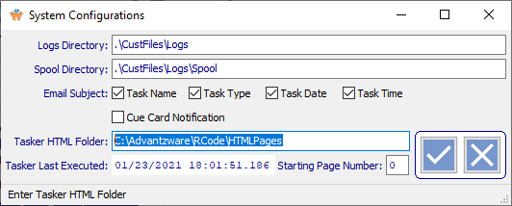

* + - Save  click to enable the fields for updating values, click again to Save any changes.
    - Cancel  if in update mode, will cancel and disable fields. If not in update mode, clicking will close this module.

Task Result / Cue Card Alert This section describes the various ways to alert users when their Submitted Tasks have completed.

1. When a user first logs in and/or the first submitted task has completed, the user will be prompted that an unviewed Task Results exists.
2. 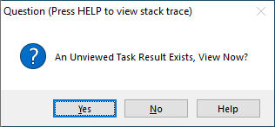
3. If the user answers YES, the Task Result will auto render using the Task Results format. Any further submissions to the Task Monitor will auto render when the Task completes.
4. If the user answers NO, this and any further submissions will auto generate a Cue Card for each completed Task if Cue Card Notification in NS3 System Configurations is toggled ON.
5. 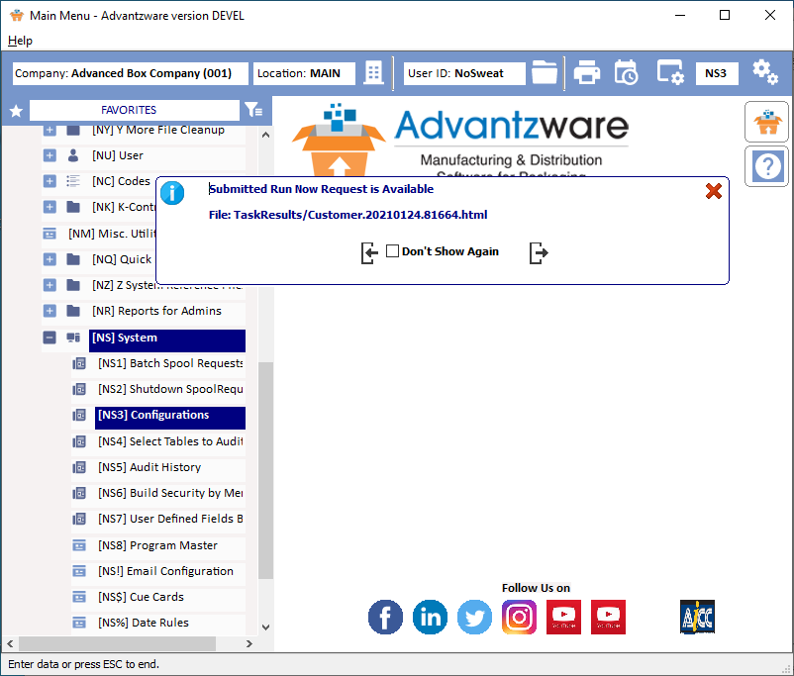
6. If the user clicks the Next  icon or the  icon, the Cue Card will continue to appear. User’s need to click Don’t Show Again to clear the Cue Card.
7. User’s should then access Task User Results ( icon via the Main Menu) to view their Task Result.

Email Configuration (NS10) Task Recipients Configuration information is needed to process Task Results that have Email Recipients associated with a Task that set how the Subject Line is constructed and whether a Cue Card alert is triggered on the User’s Main Menu.

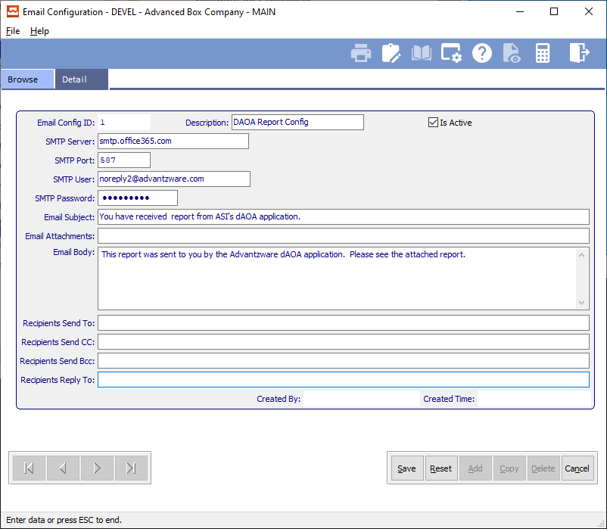

Email Configuration (NS10) Task Monitor Not Running Notification Configuration information is needed to process Task Results that have Email Recipients associated with a Task that set how the Subject Line is constructed and whether a Cue Card alert is triggered on the User’s Main Menu.

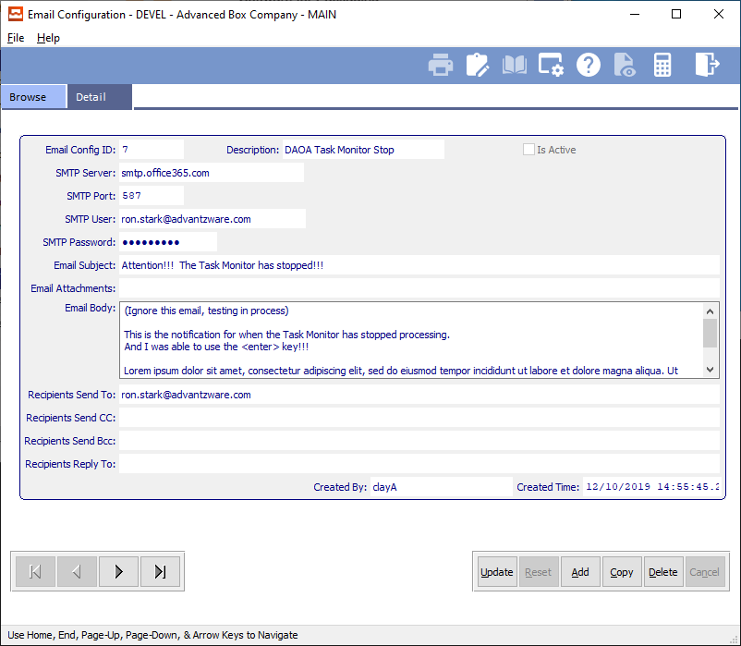

Jasper Starter The Dynamic Task framework relies on the installation of Jasper Starter to be installed on the server in which Task Monitor is running. The Task Monitor can run anywhere on any computer within the network, however, Jasper Starter needs to be installed. It is not recommended more than one Task Monitor be running simultaneously, although it is designed to function successfully. To install Jasper Starter, navigate via Windows Explorer to <drive>:\Install\ReportWriter and execute jasperstarter-3.4.1-Setup.exe. Follow the screen shots below, which requires the installed to simply take all the default settings. The installation person should have Administrator privileges.

* Installation of jasperstarter-3.4.1-Setup.exe

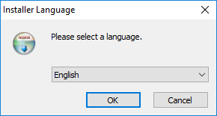

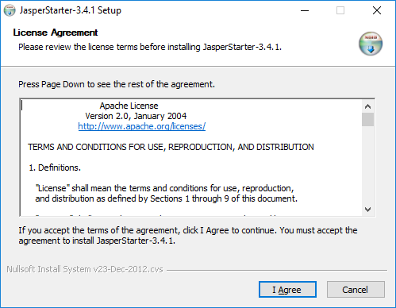

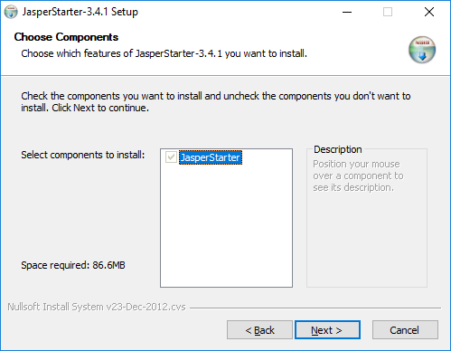

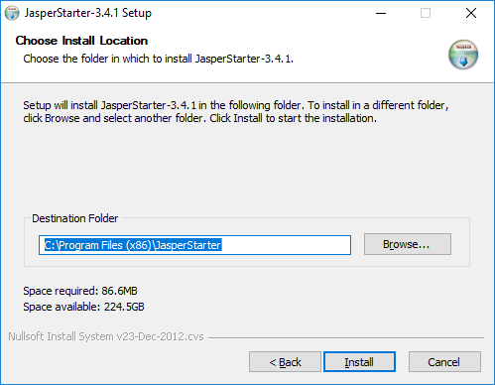

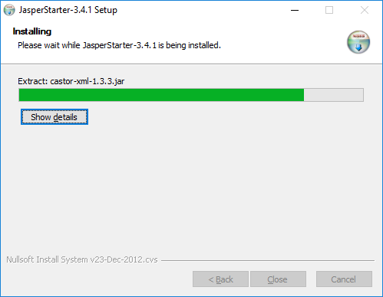

Sometimes expected issue, simply click OK.

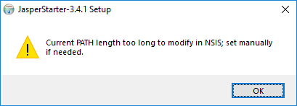

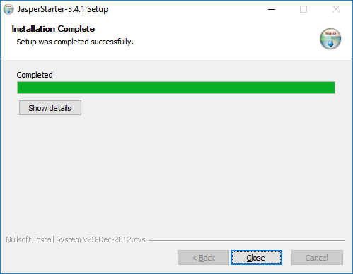

* Verification of install To ensure Jasper Starter installed correctly, run Windows Control Panel

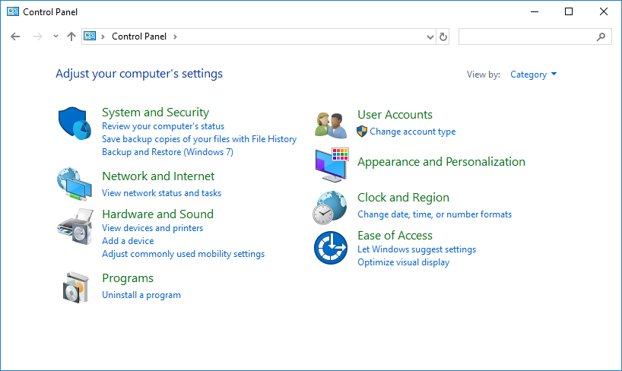

Click on System and Security

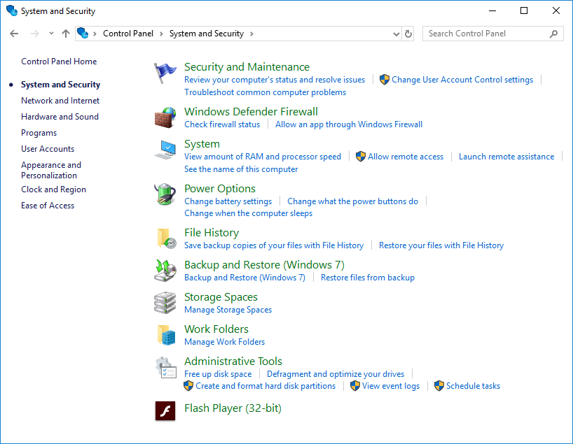

Click on System

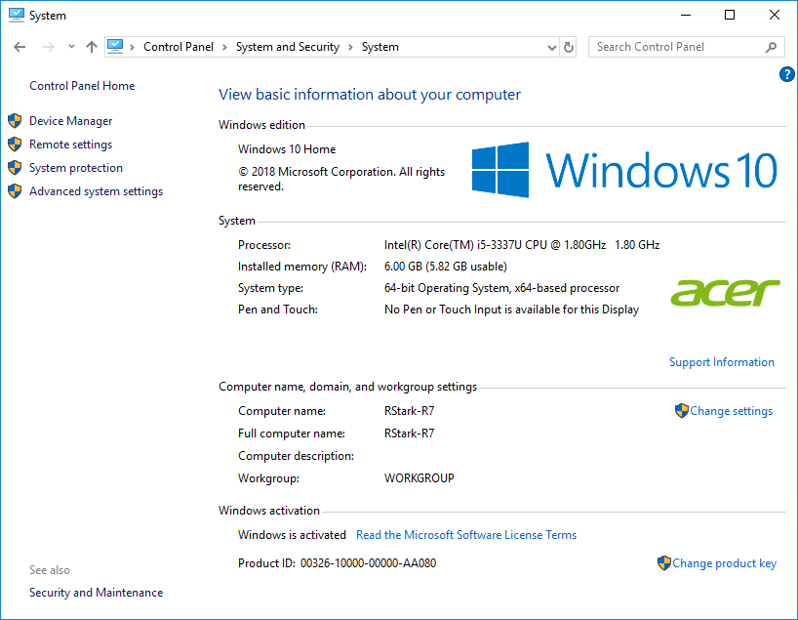

Now select Advanced System Settings

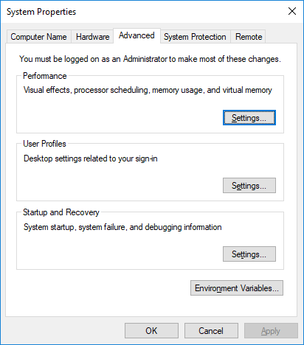

Click Environment Variables

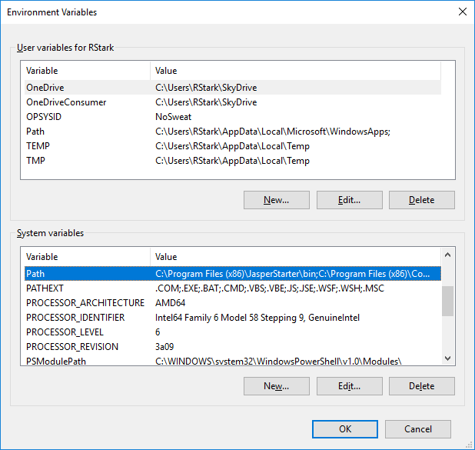

Select the Variable “Path” under System variables and click Edit

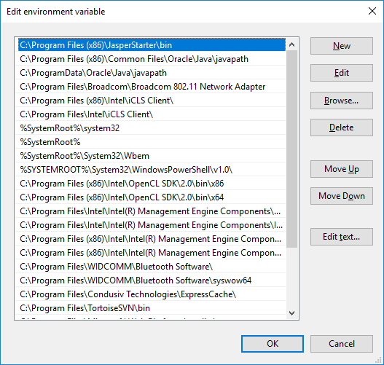

An entry for JasperStarter\bin should exist indicating a successful installation of Jasper Starter.

Another excellent test is to open a Command Prompt (cmd.exe) and type:

jasperstarter -h

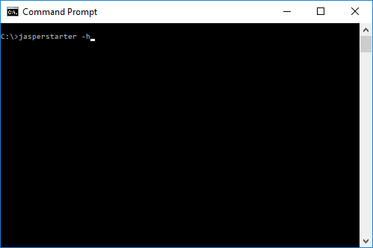

NOTE: JasperStarter relies on the appropriate Java version being installed. If JasperStarter needs Java installed, an auto popup inside a web browser will render and prompt for downloading and installing the needed Java version. Follow the defaults and after installing, re-type the above jasperstater -h.

Below is the correct response to the -h option.

